Infect1: Meningitis 2
Infect2: Ludwigs angina 4
Infect3: Syphilis 4
Infect4: Pneumonia 6
Infect5: Typhoid 8
Infect6: Diarrhea(Bacterial Enteritis) 9
Infect7: Diarrhea (Bacterial enteritis) 10
Infect8: Diarrhea 11
Infect9: Gallstones 12
Infect10: Sinusitis 13
Infect11: Urinary Tract Infection 14
Infect12: Scrub Typhus: 15
Infect14: Giardiasis 17
Infect15: Dengue 18
Infect16: STD - Chancroid 19
Infect17: Typhoid 20
Infect18: Cholera 21
Infect19: Chicken pox 22
Infect20: Urinary Tract Infection 23
Pediatric Infectious Diseases Case Studies 24
Infect21: Tuberculous Meningitis 24
Infect23: Mononucleosis 25
Infect24: Hepatitis E 26
Infect25:Pelvic Inflammatory Disease 27
Infect26: Herpes 28
Infect27: Pharyngitis 29
Infect28: Tuberculosis 30
Infect29: Influenza 31
Infect30: Malaria 32
Infect31:Malaria 33
Infect32: Pneumonia in HIV Positive Patient 34
Infect33: Kala Azar 36
Infect34: Amoebic Liver Abscess 37
INFECT35: HIV 38
Infect36: Tuberculosis 40
Infect37: Leprosy 41
Infect38: Leprosy 42
Infect39: Leg Ulcer 44
Infect40: HIV 46
Infect41: HIV with Tuberculous Lymphadenitis 48
Infect44: Dengue 49
Infect46: Sinusitis 50
Infect47: Pharyngitis 51
Infect49: Dengue 52
Infect50: Leprosy 55
Infect51: Tuberculosis 56
Infect52: Pneumonia 58
Infect53: Acute Viral Hepatitis 59
Infect54: Urinary Tract Infection 60
Infect55: Appendicitis 61
Infect58: Tuberculosis 62
Infect60 Cerebral Malaria 64
Infect61 Malaria 65

Infect1: Meningitis
HISTORY
A 19-year-old female develops fever, headache, and a maculopapular rash on her trunk three days after returning home from college for spring recess. Subsequently, she experiences nausea, vomiting, photophobia, followed by a petechial rash which spreads Within hours from her extremities to her trunk. On the way to hospital she becomes agitated and combative. There is no history of drug allergy or tick exposure.
PHYSICAL EXAMINATION
Temperature, 103.69 F. pulse, 120 per minute. Respiration; 32 per minute. Blood pressure, 100/65 mm Hg. She is alert and oriented but combative, complaining of an intense headache.
Examination of her skin reveals a diffuse petechial (red spots) rash comprised Of lesions Of varying size and shape over her extremities and trunk. The larger ecchymotic lesions are concentrated on her legs and back. Nuchal rigidity is present, and flexion Of the neck produces knee and hip flexion (Brudzinski's sign). Fundoscopic exam not demonstrate papilledema. Chest and abdomen are normal. Neurological examination reveals localizing signs.
LABORATORY DATA
Hb - 11.8
White blood cell count - 16, 200 (80% polymorphonuclear cells, bands, lymphocytes)
Urinalysis - normal

Citation: Pegram, P. Samuel, and Joseph Eggleston Johnson. Antibiotics In Clinical Medicine : Case Studies : 50 Case Histories Related to the Antibiotic Treatment and Prophylaxis of Infectious Diseases. Garden City, NY: Medical Examination Pub. Co., 1981.

Infect2: Ludwigs angina
HISTORY
Swelling After a Tooth Extraction. A 44-year-old man with a long history of poor dental hygiene develops progressive fullness under the chin and pain associated trismus and dysphagia five days after extraction of his right third molar. He reports fever, chills, and some difficulty with breathing particularly when he reclines. He denies any drug allergy.

PHYSICAL EXAMINATION
Temperature, 102.40 F. Pulse, 124 per minute. Respiration, 32 per minute. Examination Of the neck reveals symmetrical massive brawny, non-pitting Of the submandibular
His mouth can be opened Only 2-3 cm, and the tongue is moderately enlarged and elevated. He has advanced peridontal disease. There is no disease of the lymph nodes. Chest and abdominal evaluation is within normal Limits.

LABORATORY DATA
Hgb - 14.2
White blood cell count - 16.800/Q1 mm (62% segmented neutrobands, lymphocytes, 3% monocytes)
Erythrocyte sedimentation rate - 82 mm/hour
Roentgenographic studies:
head and neck - soft-tissue swelling With some impingement on the posterior pharynx mandibular panorex - multiple erosions around the root of tooth and a probable abscess Site at third right lower molar

Citation: Pegram, P. Samuel, and Joseph Eggleston Johnson. Antibiotics In Clinical Medicine : Case Studies : 50 Case Histories Related to the Antibiotic Treatment and Prophylaxis of Infectious Diseases. Garden City, NY: Medical Examination Pub. Co., 1981.

Infect3: Syphilis

HISTORY

A 22 year old male presents with a painless lesion on his penis of eight days duration. Over the past two days he has experienced generalized weakness, mild sore throat and groin swelling. He denies discharge from the urethra, previous sexually transmitted disease, and any drug allergy. He is married and sexually active.

PHYSICAL EXAMINATION
Temp 99F
Pulse 92/min
Respiratory rate 20 per minute
BP 120/80 mm Hg

Abnormal physical findings are limited to the genital and inguinal (around the groin) regions. A 4 by 6 mm indurated, clean based ulcer is present on the upper shaft of the penis along with enlarged inguinal nodes which are round, freely movable and firm.

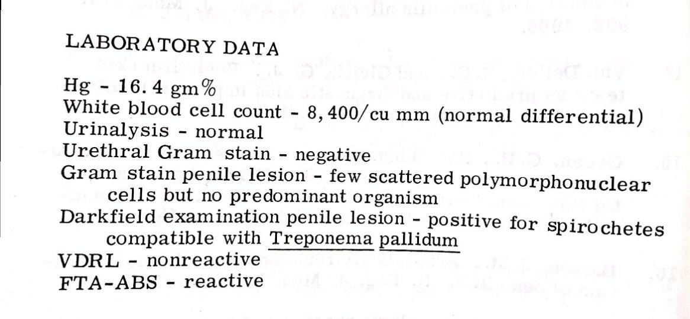

Infect4: Pneumonia

HISTORY

A 48 year old alcoholic man develops a watery nasal discharge and mild sore throat. Two days later he experiences a sudden shaking chill, fever, difficulty breathing, right sided chest pain, and a cough productive of pinkish, blood streaked sputum. Shortly thereafter he notices fever blisters on his right upper lip. His condition quickly worsens, and he is brought to the center with bluish discoloration of the skin and acutely ill. He denies recent weight loss, previous history of pneumonia, or drug allergy.

PHYSICAL EXAMINATION

Temp 103.6F
Pulse 128 per minute
Respiration 48 per minute
BP 105/60 mm Hg

He is acutely ill with rapid and shallow respirations. Herpes labialis ( and lip cyanosis are present. His eyes, ears, nose and pharynx are unremarkable. Chest examination reveals right lower lobe abnormalities including dullness to percussion, increased tactile fremitus, bronchial breath sounds, whispered pectoriloquy, egophony The remainder of the exam is normal specifically, there are no skin rashes, meningeal signs, or heart murmurs.

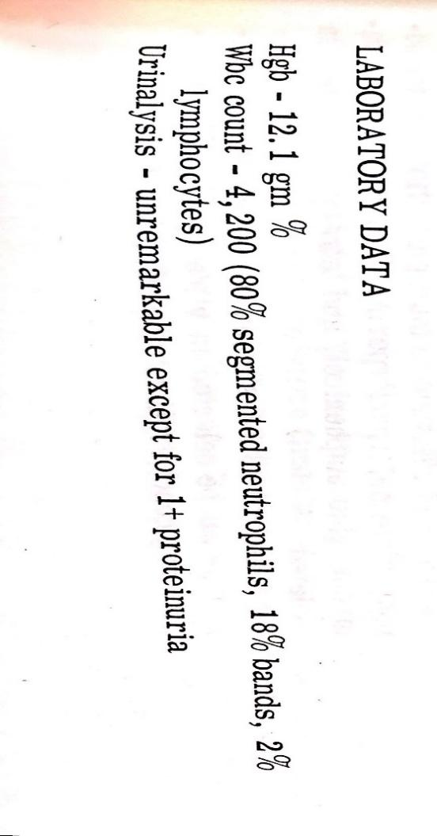
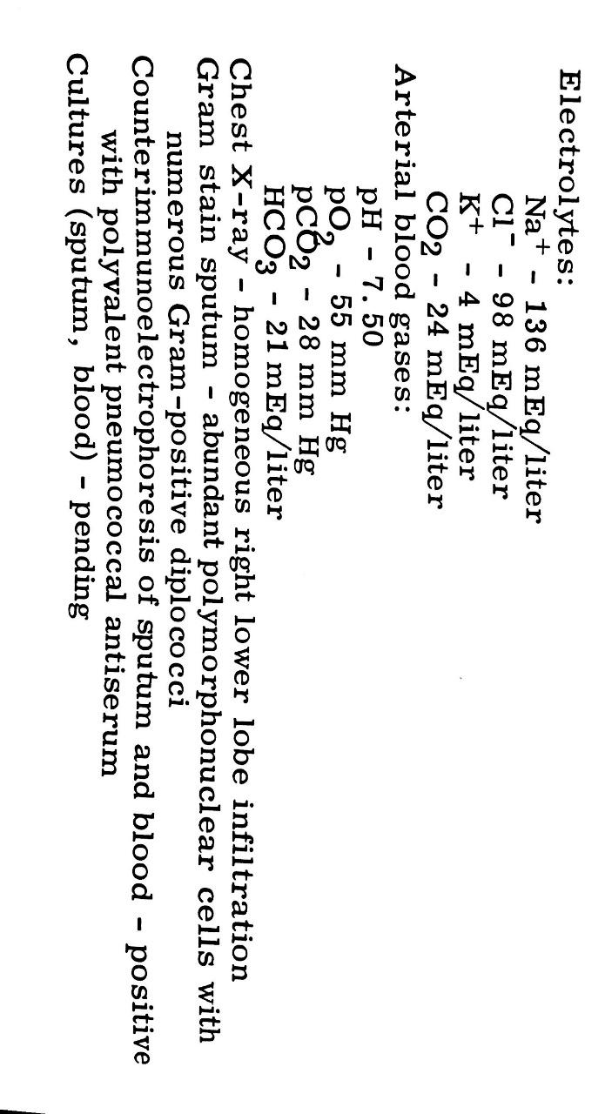

Infect5: Typhoid
HISTORY

A 64 year old female develops fever, malaise, anorexia, headache, and myalgias. After two days her fever is remittent in nature and accompanied by chills and diaphoresis. On admission to hospital three days later she is experiencing diarrhea, diffuse abdominal pain, a cough, and mild confusion.

PHYSICAL EXAMINATION
Temperature, 102.60 F.
Respiration, 28 per Pulse, 72 per minute. She appears acutely ill and has multiple 2-4 mm
erythematous maculopapular lesions that blanch on pressure on her upper abdomen. Cervical lymphadenopathy is present. Chest exam is normal. The abdomen is tender and distended
with mildly hypoactive bowel sounds. Both spleen and liver are tender and probably enlarged. The patient is lethargic otherwise neurologically normal.

LABORATORY DATA
Hgb- 13.6
White blood cell count — 10, 000/cu mm (70% segmented neutro-
phils, 10% bands, 16% lymphocytes, monocytes, eosinophils)
X-rays (chest and abdominal upright) - normal
Urinalysis - 1+ proteinuria
EKG - normal
Platelet count — 100, 000/cu mm
Alkaline phosphatase - 120 U/ L
LDH - 275 UTL
SGOT - 50 U/L
Blood culture — positive for Salmonella typhi
Stool culture — negative for enteric pathogens

Infect6: Diarrhea(Bacterial Enteritis)

HISTORY

An adult male develops a fullness in his abdomen, a loss of appetite, and nausea two days after ingesting raw meats. Shortly thereafter, he begins to have large number of liquid stools, initially brown and then clear, which contain a small amount of mucus and which are not malodorous.

PHYSICAL EXAMINATION
Temperature – 98.8 F
Pulse- 100 beats/min
Respiration – 24 per minute
BP – 120/75 mm Hg.
He is alert and complaining of uncontrollable diarrhea and a slight thirst. The physical examination is normal except for increased bowel sounds.

LABORATORY DATA

Hb- 14.8 gm%
WBC count – 8000/cu mm (normal differential)
Urinalysis – normal
Stool examination –
Microscopic – a few white and red blood cells.
Dark field- multiple vibrios
Culture- presumptive Vibrio cholerae

Infect7: Diarrhea (Bacterial enteritis)
HISTORY
A 48- year old female returns from a two week holiday in Mexico. Three days later, she develops fever and diffuse abdominal cramping followed by voluminous watery stools. Over the next 48 hours she notices a decrease in fever but an increase in the number of stools. Although the volume of the stools diminishes, she begins experiencing fecal urgency and tenesmus along with bloody mucoid bowel movements. She denies any recent antibiotic therapy or drug allergy.

PHYSICAL EXAMINATION

Temp – 104.6 F
Pulse – 120 per minute
RR – 28 per minute
BP – 120/75 mm Hg
She appears mildly dehydrated, but no rash is present. The abdomen is tender especially over the lower quadrants, and the bowel sounds are hyperactive. Proctosigmoidoscopy is very painful and reveals hyperemic, friable rectal mucosa, areas of ecchymosis and mild ulceration.

LABORATORY DATA
Hb – 12 gm%
WBC – 14,500/cu mm
Urinalysis – normal
Fecal smear – numerous sheets of polymorphonuclear or leukocytes without evidence of Entamoeba histolytica or other pathogens.
Liver enzymes – normal
Amebic indirect hemagglutination test – negative
Fecal culture – positive for Shigella species (identification and sensitivities pending)
Electrolytes – normal

Infect8: Diarrhea
HISTORY
A previously healthy 21 year old woman begins having lower abdominal cramps which are somewhat relieved by passing stools. Intermittent cramps have occurred over the past 5 days and are associated with 6-10 foul smelling stools per day which become increasingly watery. On the sixth day the stools are bloody, and the patient has generalized weakness, muscle pain, nausea, and a rigor.

PHYSICAL EXAMINATION

Temp 101.4F
Pulse 92 beats per minute
Respiration 20 per minute
BP 120/85 mm of Hg
The physical examination is completely normal except for lower abdominal tenderness on both sides without rebound.

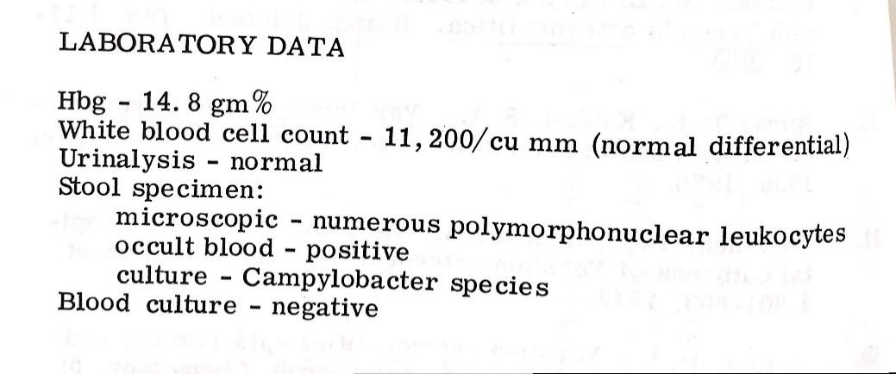

Infect9: Gallstones
HISTORY

A 48 year old female presents with recurrent pain which radiates to the right scapula. Four months previously she underwent an abdominal ultrasonographic exam which demonstrated several gallstones but no evidence of bile duct dilatation or other abdominal abnormality. Three similar attacks have happened in the past but cleared spontaneously, but the present symptoms (low grade fever, nausea, vomiting, and anorexia) have now persisted and intensified during the preceding 72 hours. She denies chills, changes in her bowel movements, genitourinary problems or pulmonary symptoms.

PHYSICAL EXAMINATION
Temp 101.2 F
Pulse 108 beats/min
Respiration: 24 per minute
BP 135/85 mm of Hg

The patient is an obese female complaining of right upper quadrant abdominal pain but is in no acute distress. Her sclerae have a subtle yellowish hint but her skin appears normal. Chest examination is within normal limits. The right subcostal region is tender to palpation and “Murphy’s sign” is elicited on deep breathing. No abdominal organ enlargement is felt, and no masses are palpated. The remainder of the exam is unremarkable.
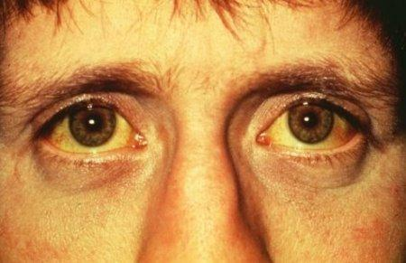

Infect10: Sinusitis
HISTORY
A 38 year old woman complains of pain over her right cheek and upper teeth associated with a purulent nasal discharge. She relates the onset of her present problem to a viral cold which began two weeks previously and progressed symptomatically to include nasal obstruction, a non postural headache, and a low grade fever. Despite the use of decongestants and nasal sprays she has not improved. She denies antibiotic therapy, recent dental problems, allergies, or previous sinus infections.

PHYSICAL EXAMINATION
Temp 100.6 F
Tenderness to palpation of the right cheek is present but no discoloration is noted. Eyes and ears are normal. There are scattered small dental caries but no obvious abnormalities in the gums, and the pharynx is clear. Examination of the nose reveals purulent material in the right middle meatus. Transillumination of the right maxillary sinus in a darkened room demonstrates complete opacity. Frontal sinuses are normal to palpation and transillumination. Neurological examination is normal.

LABORATORY DATA

Hb – 14.2 gm%
WBC – 9500 (normal differential)
Sinus X rays – opacity at right maxillary sinus

Infect11: Urinary Tract Infection
HISTORY
23 year old woman presents to her doctor complaining of 1 day of increased urinary frequency, painful passage of urine and sensation of incomplete voiding. She is otherwise healthy, takes no medications, and is sexually active, condoms for contraception. She says she does not have fever, chills, vaginal discharge, or flank pain.. Sexually active with one partner, no history of sexually
transmitted diseases

Infect12: Scrub Typhus:
HISTORY
A 16-year-old boy presents to a local hospital with fever, frontal headache and severe body aches for two days. He has vomited two to three times during the illness and has not passed any urine for the previous 12 hours. He does not have a cough, coryza or shortness of breath. He has been attending school until his illness. He had been fishing in an urban water stream five days prior to falling ill.
PHYSICAL EXAMINATION
The boy looks ill and drowsy. He is jaundiced and has subconjunctival haemorrhages (Figure 27-1 ). There is no neck stiffness, however there is severe muscle tenderness, mainly involving the abdominal wall and in the calves so that the patient finds it difficult to walk. There is no lymphadenopathy. The liver is palpable at 4 cm below the right costal margin and is tender. The spleen is not palpable. There is mild bilateral renal angle tenderness. Body temperature is 38.3°C. The pulse rate is 100 bpm and is low in volume. The blood pressure is 90/60 mmHg. The cardiac apex is not shifted. Examination of the lungs and the CNS are normal.
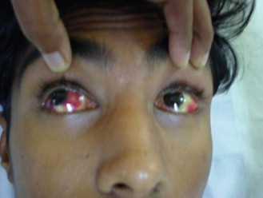

Further Investigations
The laboratory findings are summarized in Table 27-1 . The urine microscopy shows 20 red blood cells per high-power field, proteins ‘+’ and granular casts ‘+’. A chest radiograph is normal. An ECG shows sinus tachycardia.
LABORATORY RESULTS
Parameter | Patient | Reference
WBC (×10 9 /L) (neutrophils : lymphocytes) | 5.7 (68%: 31%) | 4–10
Haemoglobin (g/dL) | 14.8 | 12–16
Platelets (×10 9 /L) | 96 | 150–350
AST (IU/L) | 64 | 13–33
ALT (IU/L) | 58 | 3–25
ALP (IU/L) | 246 | 40–130
Serum bilirubin total (µmol/L) | 77 | 13.7–30.8
Serum bilirubin direct (µmol/L) | 54.7 | <5
Blood urea nitrogen (µmol/L) | 20.7 | 2.5–6.4
Serum creatinine (µmol/L) | 212.2 | 71–106
C-reactive protein (mg/L) | 48 | <5

Citation: Rothe, Camilla. Clinical Cases In Tropical Medicine. [Place of publication not identified]: Saunders Ltd., 2014.

Infect14: Giardiasis
Clinical Presentation
HISTORY
A 33-year-old man complaints of passage of loose stools (four or five episodes per day) for the past two weeks. He reports weight loss, anorexia, malaise, flatulence and abdominal cramping when passing stool. For the past three days he has had bloating and distension after intake of milk products with an urge to pass stool. He has mild nausea, but no fever. Stools were watery earlier but he went to a local pharmacy and was given ciprofloxacin which he took for five days, ending two days previously, and stools are now three or four per day, mushy, greasy and foul-smelling.
PHYSICAL EXAMINATION
A 33-year-old man, 180 cm, 72 kg (reports a 4 kg weight loss), mild nonspecific abdominal tenderness. No signs of dehydration. The rest of the examination is normal.
Citation: Rothe, Camilla. Clinical Cases In Tropical Medicine. [Place of publication not identified]: Saunders Ltd., 2014.

Infect15: Dengue
HISTORY
A 16-year-old girl presents to the outpatient department of an urban hospital in Vietnam having had fevers of 39–40°C, headache, lethargy and muscle aches for five days. Today she has vomited three times and is complaining of abdominal pain. She also noticed some bleeding from her gums after brushing her teeth this morning. She is normally fit and well and has not travelled outside the city.
PHYSICAL EXAMINATION
On examination, the patient looks lethargic but has a GCS of 15/15. Her temperature is 39°C, blood pressure is 94/68 mmHg, pulse 88 bpm and the respiratory rate is 20 breath cycles per minute. There is a maculopapular rash on the chest, abdomen and extremities that is fading ( Figure 9-1 ). Cardiovascular and respiratory examination is normal. There is mild abdominal tenderness and the liver edge is palpable, bowel sounds are normal. The spleen is not enlarged and there is no palpable lymphadenopathy.
LABORATORY DATA

Parameter | Patient | Reference Range
WCC (x10 9 /L) | 2.8 | 4–10
Haemoglobin (g/dL) | 14.1 | 12–16
Haematocrit (%) | 43.8 | 36.1–44.3
Platelets (x10 9 /L) | 38 | 150–300
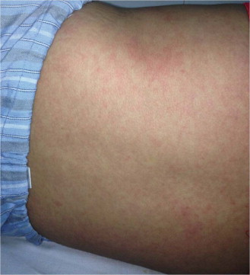

Citation: Rothe, Camilla. Clinical Cases In Tropical Medicine. [Place of publication not identified]: Saunders Ltd., 2014.

Infect16: STD - Chancroid
HISTORY
A 29-year-old man comes to your clinic in The Gambia complaining of painful sores involving his private parts for seven days. He has been previously well. He admits to having had sex with a commercial sex worker two weeks ago, when he had not used a condom. He is in considerable pain and is only able to walk with difficulty because of these sores. He is afebrile and well nourished.
PHYSICAL EXAMINATION
General examination is unremarkable. The only abnormality is the presence of numerous painful ulcers on his penis, scrotum and inner thigh ( Figure 12-1 ). The ulcers are tender, soft and bleed on contact. There is no inguinal lymphadenopathy.
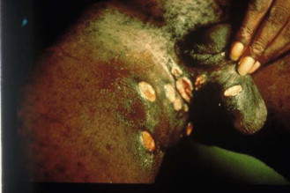
Citation: Rothe, Camilla. Clinical Cases In Tropical Medicine. [Place of publication not identified]: Saunders Ltd., 2014.

Infect17: Typhoid
HISTORY
A 16-year-old girl presents to the emergency room of a hospital in Malawi because of fever, generalized abdominal pain and frontal headache for the past five days. There is no history of diarrhoea. She delivered a baby five months ago. A HIV test done in the antenatal clinic was negative. Her further past medical history is unremarkable. She lives with her parents, her three siblings and her baby in an urban high-density area. There is no running water and no electricity in the house. They fetch water from a community tap. She went to primary school but recently dropped out during her pregnancy.
PHYSICAL EXAMINATION
The patient is a 16-year-old girl in a fair nutritional state. Temperature 38.1°C, blood pressure 110/60 mmHg, pulse 78 bpm, respiratory rate 20 breath cycles per minute, Glasgow Coma Scale 15/15. There is mild scleral jaundice, no neck stiffness. The examination of the abdomen shows diffuse tenderness but no guarding. The liver is not enlarged, the spleen is palpable at 2 cm below the left costal margin. The chest is clear and there is no lymphadenopathy. Pelvic examination is unremarkable and there is no vaginal discharge.
LABORATORY RESULTS
Her laboratory results on admission are shown in Table 13-1 . Thick smear for malaria parasites is positive. Liver function tests are not available since reagents are out of stock.
Table 13-1Laboratory Results on Admission
Parameter | Patient | Reference
WBC (×10 ⁹ /L) | 3.2 | 4–10
Haemoglobin (mg/dL) | 10.9 | 12–14
MCV (fL) | 90 | 80–99
Platelets (×10 ⁹ /L) | 164 | 150–400
Creatinine (µmol/L) | 71 | < 80

Citation: Rothe, Camilla. Clinical Cases In Tropical Medicine. [Place of publication not identified]: Saunders Ltd., 2014.

Infect18: Cholera
HISTORY
A 22-year-old woman from a village near Dhaka, Bangladesh, is brought to the district hospital emergency room with a history of passing 12–15 large-volume stools which resemble diluted milk or rice water with white flakes in the past day. Her husband reports that she became unresponsive about an hour previously and he hired a rickshaw to bring her to the hospital. He says that she had not complained of pain and did not have fever.
The patient has recently returned from her village after attending a religious festival, where water was supplied in large metal containers. Her husband reports that there were five or six people who had attended the same event and who were also ill with diarrhoea, although none as severely affected as his wife.
PHYSICAL EXAMINATION
A thin young woman, who is stuporous, and responds minimally to a painful stimulus (Glasgow Coma Scale 9/15). She is afebrile, with sunken eyes, dry mouth and eyes, and a scaphoid abdomen. A skin pinch returns very slowly. Her pulse rate is 110 bpm, low volume, and her blood pressure is 90/50 mmHg. The remainder of her systemic examination is normal.
Laboratory Results
The results of her blood tests on admission are shown in Table 14-1 .
Biochemical Test Results on Admission
Parameter | Patient | Reference
Sodium (mmol/L) | 134.8 | 135–145
Potassium (mmol/L) | 3.0 | 3.5–5.0
Chloride (mmol/L) | 103.8 | 98–108
Bicarbonate (mmol/L) | 11.4 | 23–28
Lactic acid, venous (mmol/L) | 4.1 | 0.67–1.8
Creatinine (µmol/L) | 203.3 | 62–115
Blood urea nitrogen (mmol/L) | 8.6 | 2.9–7.1

Citation: Rothe, Camilla. Clinical Cases In Tropical Medicine. [Place of publication not identified]: Saunders Ltd., 2014.

Infect19: Chicken pox
CASE 10: CHICKENPOX WITH NECROTIC SKIN LESIONS
HISTORY

An 18-month-old, Indian boy was in good health until 5 days prior to admission when varicella lesions appeared on his trunk and spread to his extremities. Two brothers had just recovered from chickenpox. Three days before admission his mother had noticed a tender, red area on the left anterior thigh. His temperature rose to 39.50 C, and he became anorectic and lethargic. On the day before admission he was seen in an emergency room and given an intramuscular injection of penicillin for "infected varicella". On the following day, he was referred to a university medical center because of the induration and dusky blue color of the left thigh.
PHYSICAL EXAMINATION: Admission examination showed an 18-month-old boy who was alert and in no acute distress. Temperature was 38 C, pulse 135/min, respirations 45/min, height 83 cm., weight 19 kg. Crusted lesions were distributed over the face and scalp and trunk. A 3 x 7 cm. area of necrotic tissue with a raised blue center and flat erythematous border was present on the front side of the left thigh. Several 1 x 1 cm. nodes were present around the thigh and groin on both sides. The circumference of the thigh 8 inches above the knee was 3 inches larger on the left than the right. A "strawberry tongue" was present.
LABORATORY VALUES:
Hemoglobin, 13.3 grams%.
Hematocrit, WBC. 38, 400 with 85% neutrophils, 14% lymphocytes and 1% monocytes.
Platelets, 312, 500/cU. mm.
Urinalysis was normal.

Citation: Frothingham, Thomas E. Pediatric Infectious Diseases Case Studies : 54 Case Histories Related to Pediatric Infectious Diseases. Garden City, N.Y.: Medical Examination Pub. Co., 1978.

Infect20: Urinary Tract Infection
CASE 16: LOW GRADE FEVER, DECREASED APPETITE AND IRRITABILITY IN AN INFANT
HISTORY

A 9-month-old baby girl presented with low grade fever decreased appetite and irritability Of 2 weeks duration. She had occasional vomiting but no diarrhea or symptoms Of upper respiratory tract infection. The mother had noticed that the patient had not been gaining weight over the past month. Patient smiled at 2 months, had no head lag at 4 months, and reached out for objects at 7 months of age. Past medical history is essentially negative.
PHYSICAL EXAMINATION

Temperature 39. C, Height 77 cms., Weight 7. 5 kgm., Pulse 100/ minute, Respirations 28/minute. The patient was quite irritable, normal ear drums, no signs of an upper respiratory tract infection, clear lungs, regular sinus rhythm, soft abdomen without enlargement of organs Or masses, normal neurologic examination and no vaginal dis-charge. External genitalia were normal and the kidneys were palpable on both sides.
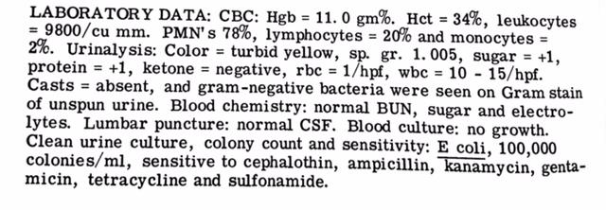
Citation: Frothingham, Thomas E. Pediatric Infectious Diseases Case Studies : 54 Case Histories Related to Pediatric Infectious Diseases. Garden City, N.Y.: Medical Examination Pub. Co., 1978.

Pediatric Infectious Diseases Case Studies

Infect21: Tuberculous Meningitis
CASE 23: FEVER, VOMITING, DROWSINESS, NECK STIFFNESS AND HEADACHE
HISTORY
A 5-year-old boy presented with the chief complaint of low grade fever of 2 weeks duration associated with loss of appetite and malaise. Three days prior to admission, he developed a non- throbbing generalized headache, neck stiffness and progressive drowsiness. He became lethargic and had several episodes of vomiting not related to food intake. The past medical history was essentially negative. There was no history of head trauma. The patient lived with his grandmother who gave a history of chronic cough.
PHYSICAL EXAMINATION

Temp. 38. 90F, pulse 90/minute, B. P. 110/75 mm Hg. , respiratory rate 28/ minute, weight 18 kg. Physical examination revealed an ill-appearing, showing no interest in things around him and drowsy young boy With a stiff neck. Eyes are normal. The patient has positive Kernig's and Brudzenski' s signs with increased deep tendon reflexes in both lower extremities. Babinski' S sign was negative. There were no localizing neurological deficits. There w.as no generalized disease of lymph nodes. The remainder Of the physical examination was Within normal limits.

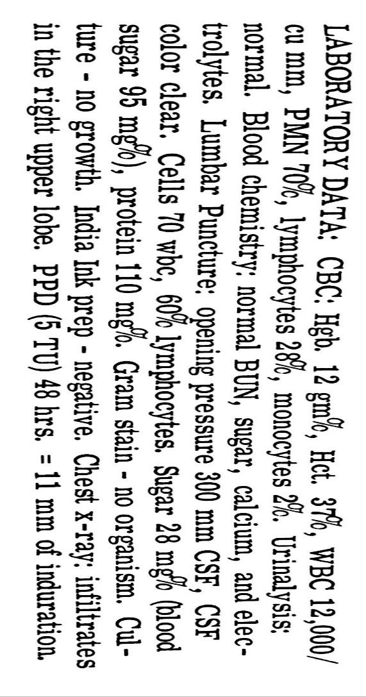
Citation: Frothingham, Thomas E. Pediatric Infectious Diseases Case Studies : 54 Case Histories Related to Pediatric Infectious Diseases. Garden City, N.Y.: Medical Examination Pub. Co., 1978.

Infect23: Mononucleosis
HISTORY
A 23-year-old woman presents to her private physician because of sore throat and a skin rash. She is in excellent health until 8 days earlier when she developed sore throat, malaise, chills, and fever. She was seen by another physician and given ampicillin capsules. Her constitutional symptoms continued for 4 or 5 days and then begun to abate, but the pharyngitis became progressively worse. The day before presentation she noted a generalized pruritic erythematous rash.
PHYSICAL EXAMINATION
Physical examination reveals a temperature of 100 F. The pharynx is erythematous, and there is a whitish exudate over the tonsils and posterior pharynx. A right submaxillary node is enlarged and tender. The spleen tip is palpable in the left-upper quadrant. A generalized maculopapular, erythematous rash is present.

Citation: Cobbs, C. Glenn, Charles Kirk Avent, and Frank M Griffin. Infectious Diseases Case Studies : a Compilation of 91 Clinical Studies. 4th ed. / New Hyde Park, N.Y.: Medical Examination Pub. Co., 1986.

Infect24: Hepatitis E
HISTORY

The patient was a 49-year-old woman who presented with a 3- to 4-week history of nausea, vomiting, and periodic fevers. She had recently returned from a visit to rural areas Of India. She admitted to swimming in the Ganges River, eating in restaurants, drinking water without boiling or filtration, and having "raw" milk in her tea. She was exposed to rats, cattle, and mosquitoes. She did not take malaria or gamma globulin prophylaxis. Two days prior, she began feeling tired and "started sleeping all day." She complained Of vomiting after meals and 2 to 3 days of watery diarrhea at the Onset Of the illness that has since resolved. She had fevers every 5 days with associated arthralgias and myalgias. Her fevers were documented to 38C

PHYSICAL EXAMINATION

She was a thin woman in no apparent distress. She had a temperature of 36.9C„ pulse rate of 70/min, and blood pressure of 134/80 mm Hg reclining and 104/76 mm Hg standing. Her physical examination was significant for scleral icterus and a liver palpable at the costal margin.

LABORATORY DATA
Laboratory tests were significant for the following values: aspartate aminotransferase (AST), 4,872 U/liter, alanine aminotransferase (ALT), 3,682 U/liter, t-glutamyltransferase (GGT), 174 U/liter; and bilirubin, 6.0 mg/dl. The results of her hepatitis serologic tests were as follows: hepatitis B virus (11B) surface antigen, negative; HB surface antibody, positive; anti-HB core antibody, positive; anti-HB core immunoglobulin M (lgM) antibody, negative anti-hepatitis A virus (HAV) antibody, positive; anti-HAV IgM antibody, positive.

Citation: Gilligan, Peter H., M. Lynn Smiley, and Daniel S Shapiro. Cases In Medical Microbiology and Infectious Diseases. 3rd ed. Washington, DC: ASM Press, 2003.

Infect25:Pelvic Inflammatory Disease
HISTORY

This 16-year-old female presented to the center with complaints of crampy abdominal pain for days and vaginal bleeding. She denied symptoms of urinary tract infection and abnormal vaginal discharge and had not noted any chills Or fever. She had no nausea or vomiting. The pain increased in the 24 hours prior to presentation, and at the time of examination She also noted pain in the right upper quadrant. She was sexually active with one male partner in the preceding 3 months, and claimed to use condoms as a method of birth control. She is the mother of one child.

PHYSICAL EXAMINATION
On examination, her temperature was 38.3C, and there was exquisite tenderness in the right upper quadrant as well as the left lower quadrant. No rebound tenderness or guarding was noted. On pelvic exam, cervical motion tenderness was present, as well as right and left adnexal tenderness. No masses were palpated.

Citation: Gilligan, Peter H., M. Lynn Smiley, and Daniel S Shapiro. Cases In Medical Microbiology and Infectious Diseases. 3rd ed. Washington, DC: ASM Press, 2003.

Infect26: Herpes
HISTORY
The patient was a 20-year-old female who presented with a 4-day history of fever, chills, and myalgia. Five days prior to this she had noted painful genital lesions. On the day of admission she developed headache, photophobia, and a stiff neck. Previously, she had been in good health. She admitted to being sexually active but had no history of sexually transmitted diseases (STDs).

PHYSICAL EXAMINATION

On physical examination, she was alert and oriented. Her vital signs were normal except for a temperature of 38.5C; pulse rate was 80 beats/min, and blood pressure was 130/80 mm Hg. A general examination was unremarkable except for slight neck rigidity. Her throat was clear, and there was no lymphadenopathy.

A pelvic examination revealed extensive vesicular and ulcerative lesions on the left labia minora and majora with marked edema. The cervix had exophytic (outward-growing) necrotic ulcerations. Specimens were taken to culture for Neisseria gonorrhoeae, viruses, and Chlamydia trachomatis.

LABORATORY DATA

General laboratory tests were unremarkable. The VDRL (Venereal Disease Research Laboratory) test was negative. A lumbar puncture was done. The opening pressure was normal.

The cerebrospinal fluid (CSF) showed a mild pleocytosis with a leukocyte count of 41/gl with 21% polymorphonuclear leukocytes and 79% mononuclear cells, a glucose level of 46 mg/dl, and a protein level of 68 mg/dl (slightly elevated). The CSF VDRL test was negative.

A rapid diagnostic test was done on the genital lesion and gave positive results. Cultures from the genital lesions and CSF verified the diagnosis 2 days later. By that time the patient condition had improved after 2 days Of intravenous therapy. She was discharged home on oral medication.

Citation: Gilligan, Peter H., M. Lynn Smiley, and Daniel S Shapiro. Cases In Medical Microbiology and Infectious Diseases. 3rd ed. Washington, DC: ASM Press, 2003.

Infect27: Pharyngitis

HISTORY

The patient was a 5-year-old male who awoke on the day prior to evaluation with a sore throat and fever. His mother had him stay home from kindergarten and treated him symptomatically with tylenol. He slept well but the next day awoke still complaining of sore throat and fever, as well as headache and abdominal pain. He was an only child and neither parent was ill.

PHYSICAL EXAMINATION
On physical examination, he was noted to have a fever of 38.4C. His physical examination was significant for a 2+ (on a scale Of 1 to 4+) red anterior pharynx, tonsillar region, and soft palate. His lymph nodes at the neck at the angle of the mandible were slightly enlarged and tender. No skin lesions Or rashes were seen.

Citation: Gilligan, Peter H., M. Lynn Smiley, and Daniel S Shapiro. Cases In Medical Microbiology and Infectious Diseases. 3rd ed. Washington, DC: ASM Press, 2003.

Infect28: Tuberculosis
HISTORY

The patient was an 40 year old male who presented to the center with a 1-month history of cough, fever, and night sweats and weight loss of over 15 pounds in the last few months. His medical history was positive for HIV and diabetes mellitus. He also gives history of difficulty swallowing and smokes 1 pack per day since the past 15 years.Patient has also reported loss of appetite.

PHYSICAL EXAMINATION

On examination, patient looks weak and thin.

Citation: doctor

Infect29: Influenza

HISTORY
The patient was a 3 year old male who presented with a 4 day history of fevers. He became acutely ill and vomited during lunch. Over the next 4 days he developed fevers as high as 40C that were controlled by medications. He also developed cough, stuffy nose, and conjunctivitis. He appeared to be tired, and his parents reported that he was very sleepy. Over the next few days, his eyes had begun to itch and were painful. His parents noted that his eyes were puffy and he was sensitive to light. He has had no rashes. The patient’s lips were dried and cracked, and he had a greatly reduced urinary output. Other history pertinent to his illness is that he attended preschool twice per week, where he had multiple sick contacts. His 1 year old sibling had otitis media, some wheezing, vomiting and cough with sputum.

PHYSICAL EXAMINATION
On physical examination, he had a temperature of 38.6 C, pulse rate of 126 beats/min and RR 28/min. Significant findings include conjunctivitis in both eyes with discharge in the left eye, stuffy nose, cracked lips. He had disease of lymph nodes but no rash. His feet were slightly swollen.

Citation: Gilligan, Peter H., M. Lynn Smiley, and Daniel S Shapiro. Cases In Medical Microbiology and Infectious Diseases. 3rd ed. Washington, DC: ASM Press, 2003.

Infect30: Malaria
HISTORY
The patient was a 41-year-old man. Seven days before admission, the patient noted the acute onset of fevers with chills as well as cough and myalgias. For the next 3 days he had episodes of fevers and chills approximately three times a day. After 3 days of fever, he sought care at a local urgent care center. He told the physician that he had just returned from Africa and had not taken malaria prophylaxis. He had a white blood cell count of 2,200/gl and a platelet count of 102,000/gl. No hematocrit was reported. A purified protein derivative (PPD) test was placed.
The patient was diagnosed as having bronchitis, treated with azithromycin, and instructed to return in 48 hours to have his PPD test read. On his return, the patient was found to be hypotensive and had mental status changes. He was noted to be icteric

He was referred to the emergency room of the local hospital to "rule out hepatitis." A diagnosis was made in the hematology laboratory (Fig. 1). At the time of his diagnosis, he was noted to
have a hematocrit of 25 After 24 hours of antimicrobial and aggressive fluid therapy, he had a cardiopulmonary arrest. He was resuscitated. In the next 24 hours, he developed acute respiratory distress syndrome and became progressively hypotensive. He was transferred to a tertiary care hospital. On arrival, he was incubated and comatose.

PHYSICAL EXAMINATION
On physical examination, he was grossly icteric and tachycardic and was noted to be oozing bright red blood from his mouth and catheter sites.

LABORATORY DATA
His laboratory tests were significant for a hematocrit of 23%, platelets of 39,000/g1, prolonged bleeding times, and a 3. hemoglobin level and 25 to 50 red blood cells in his urine. He was given fresh-frozen plasma, platelets, and cryoprecipitate for his disseminated intravascular coagulation. Exchange transfusion was begun, and the patient received 7 units of packed red blood cells. His
condition continued to deteriorate, and he had a cardiac arrest from which he could not be resuscitated.

Citation: Case Study, www.austincc.edu/microbio/2993t/fjsol.htm.

Infect31:Malaria
HISTORY
A 32-year-old, previously fit woman developed a fever, and three days later became very unwell with abnormal behaviour.
PHYSICAL EXAMINATION
On examination she has a temperature of 37.5°C, is mildly jaundiced and confused, Glasgow Coma Scale 14/15. She has no rash or palpable lymph nodes, and throat and sclerae are not injected. She has some fine crepitations at the lung bases.
Citation: Rothe, Camilla. Clinical Cases In Tropical Medicine. [Place of publication not identified]: Saunders Ltd., 2014.

Infect32: Pneumonia in HIV Positive Patient
HISTORY
You are referred a 31-year-old HIV-positive man from Accident and Emergency. He has a six-week history of drenching night sweats, dry cough and increasing shortness of breath on exertion. He also reports general fatigue and a loss of about 10 kg in weight over the past five months.
He works in the retail industry. He lives with his male partner, denies any recreational drug use and has never smoked tobacco. He was diagnosed with HIV six years ago. He says that one month ago his CD4 was 280/µL. He is not yet on antiretroviral therapy (ART), or any other regular medications. There is no other significant past medical history

PHYSICAL EXAMINATION
On examination, he is alert, short of breath at rest but able to complete full sentences. He has a temperature of 39.2°C. Respiratory rate is 26 breath cycles per minute, oxygen saturation is 87% on air, 97% on 15 L O ₂ via reservoir bag. Pulse 100 bpm, blood pressure 120/70 mmHg. Chest is clear on auscultation. The rest of the physical examination is unremarkable.
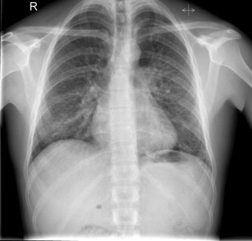

LABORATORY DATA

Parameter | Patient | Reference Range (Units)
Haemoglobin (g/dL) | 13.0 | 12–16
MCV (fL) | 81.1 | 80–99
Platelets (x10 ⁹ /L) | 233 | 150–400
WBC (x10 ⁹ /L) | 5.31 | 4–10
Neutrophils (x10 ⁹ /L) | 2.42 | 2–7.5
Lymphocytes (x10 ⁹ /L) | 2.72 | 1.20–3.65
C-reactive protein (mg/L) | 6.7 | <5
Urea (mmol/L) | 2.8 | 1.7–8.3
Creatinine (µmol/L) | 59 | 66–112
Bilirubin (µmol/L) | 4 | 0–20
ALT (U/L) | 28 | 10–50
ALP (U/L) | 97 | 40–129
Albumin (g/L) | 35 | 34–50

Citation: Rothe, Camilla. Clinical Cases In Tropical Medicine. [Place of publication not identified]: Saunders Ltd., 2014.

Infect33: Kala Azar
Clinical Presentation
History
A 7-year-old girl presents to a clinic with a four-week history of undulating fever. The fever occurs mainly in the afternoon hours accompanied by chills and sometimes convulsions. In between the febrile episodes she was initially fine and played normally. However, over time she has developed progressive anorexia, dry cough, chest pain, joint and back pain.
She has never been admitted to hospital but she has presented at another clinic recently where she received some unspecified tablets that did not bring any improvement.
Clinical Findings
The girl is alert, pale, but not jaundiced. She is severely malnourished (Z-score <3). Her vital signs are: temperature 39.6°C, pulse 96 bpm, blood pressure 100/60 mmHg. Her chest sounds clear; normal heart sounds; soft abdomen with a splenomegaly of 4 cm below the left costal margin. There are multiple enlarged lymph nodes of about 1 cm in diameter in the cervical, axillary, inguinal and epitrochlear region. There are no skin lesions and no peripheral oedema.
Parameter | Patient | Reference
WBC (x10 ⁹ /L) | 1.35 | 4–10
Haemoglobin (g/dL) | 6.8 | 12–16
Platelets (x10 ⁹ /L) | 98 | 150–300

Citation: Rothe, Camilla. Clinical Cases In Tropical Medicine. [Place of publication not identified]: Saunders Ltd., 2014.

Infect34: Amoebic Liver Abscess

HISTORY
A 45-year-old Sri Lankan man presents to a local hospital with fever, chills, headache, body aches and severe right hypochondrial abdominal pain for the past week. He has also developed a dry cough during the past few days. He has vomited twice during his illness and has lost his appetite.His abdominal pain is constant and dull in nature. It radiates to the right shoulder and is made worse when coughing and resting on the right side. The patient has been well before the current illness. He admits to consuming locally brewed alcohol (‘ toddy ’, made of coconut flowers) daily for the last 10–15 years.
PHYSICAL EXAMINATION
The patient looks generally ill, mildly dehydrated and is in pain. Temperature is 38.3°C, blood pressure 100/80 mmHg, pulse 102 bpm, respiratory rate 24 breath cycles per minute. There is no jaundice, no pallor and no lymphadenopathy. The abdominal examination reveals a tender hepatomegaly, however the tenderness is most prominent over the 6th to 9th intercostal spaces in the right mid-axillary line. The spleen is not enlarged. On auscultation there are few inspiratory crackles over the right lung base. The cardiovascular system and the nervous system are clinically normal.
LABORATORY DATA
His laboratory results are shown in Table 46-1 . A chest radiograph showed elevated right hemidiaphragm and patchy shadows in the right lower zone.
T able 46-1
Laboratory Results at Presentation
Parameter | Patient | Reference
WBC (×10 ⁹ /L) | 14.7 | 4–10
Haemoglobin (g/dL) | 12.3 | 12–16
Platelets (×10 ⁹ /L) | 224 | 150–350
AST (U/L) | 54 | 13–33
ALT (U/L) | 38 | 3–25
ALP (U/L) | 446 | 40–130
Serum bilirubin total (µmol/L) | 1.5 | 25.7–30.8
Serum bilirubin direct (µmol/L) | 10.3 | 1.7–5.1
Blood urea nitrogen (mmol/L) | 7 | 2.5–6.4
Serum creatinine (µmol/L) | 124 | 71–106
C-reactive protein (mg/L) | 48 | <6
Citation: Rothe, Camilla. Clinical Cases In Tropical Medicine. [Place of publication not identified]: Saunders Ltd., 2014.

INFECT35: HIV
HISTORY
A 52-year-old gentleman admitted with complaint of loose stools and decrease appetite of months duration. There were 15 to 20 episodes of loose stools per day, not mixed with mucus or blood. History of significant weight loss was also present. He denied complaint of fever, cough, breathlessness, ear discharge, abdominal pain, abdominal distension, burning micturition, decrease urine output, abnormal behavior, abnormal movements of limbs, yellowish discoloration of eyes or swelling of limbs. He was a chronic alcoholic. There was history of rash over back and arm 2 months back.

PHYSICAL EXAMINATION
Physical examination revealed blood pressure 110/70 mm Hg, pulse 86 beats per minute, temperature 37.20C. The patient was cachexic and had significant pallor. Mild dehydration was also present. There were markers of healed herpes zoster (Figure 23.1). There was no icterus or lymphadenopathy. Abdomen examination showed no hepatosplenomegaly. Chest, cardiovascular and nervous system examinations were inconclusive.

LABORATORY DATA
The patient's stool culture was sterile but Kinyoun's stain on stool sample showed
oocysts of Cryptosporidium. Table 23.1 shows patients CD4 cell counts, viral load and other parameters.

He was started on 3 drugs anti-retroviral therapy: emtricitabine, efavirenz and tenofovir, intravenous fluid, along with nitazoxanide for cryptosporidial infection. The patient's general condition improved in 5 days and he got discharged from the hospital on combination of antiretroviral therapy
cotrimoxazole tablets.
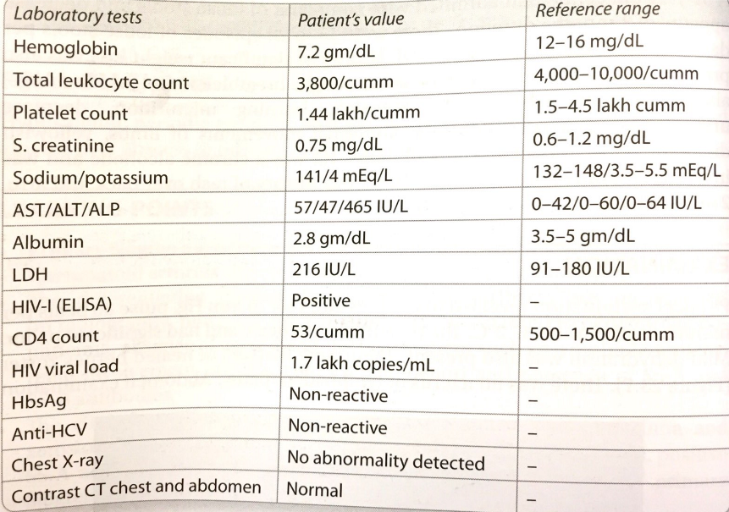

Citation: Kakar, Atul, and Atul Gogia. Case Studies in Internal Medicine. Jaypee Brothers Medical Publishers, 2014.

Infect36: Tuberculosis
HISTORY

A 38 year old black male consults you because of cough, sputum production and mild hemoptysis. He has had evening rise of temperature for the past one month and claims to have lost 30 lbs. over a three month period.

PHYSICAL EXAMINATION

On exam he appeared to be chronically ill and wasted. Cavernous breath sounds are heard over the right apex. Chest x-ray shows fluffy infiltrates and some amount of contraction of the right upper lobe. There is a cavity in the superior segment of the right upper lobe. A working diagnosis of tuberculosis is made.

Infect37: Leprosy

HISTORY
A 34 year old woman was diagnosed with lepromatous leprosy (multibacillary leprosy) after complaining of a persistent pruritic rash throughout her body. The diagnosis was made after a skin biopsy of skin lesions on the abdomen revealed acid-fast bacilli. The patient was not aware of her diagnosis until she presented to physician. The patient had two children, including an infant; she had stopped smoking several years ago and appeared to be well nourished.
Her medical history indicated that her symptoms started five years ago, with cramping and spasms of her arms. She noted that her wrists felt like they were falling asleep at times, along with needle-like pain that would occasionally erupt. Additionally, she reported a significant amount of fatigue and stress. The patient’s medical record indicated a diagnosis with depression; her initial visits for the skin condition included initial diagnoses of atopic dermatitis and urticaria before the biopsy was taken. The patient was prescribed ibuprofen, fluoxetine and hydroxyzine.

During the course of the interview, the patient revealed that she had worked with flowers extensively several years ago her family kept a variety of household pets such as dogs and birds. The interview was unable to determine if any other family members, locally or out-of-state, had similar dermatological complaints; however, her infant reportedly had a fungal infection suggesting potential infection of the child.
PHYSICAL EXAMINATIONS
The physical exam revealed numerous lesions throughout her body, including those on her nasal bridge area, cheeks, abdomen and back. These lesions were macular in nature and did not exhibit significant plaque, dryness or significant discoloration other than an erythematous appearance. The soles of her feet appeared to be usually dry and callous, and her legs appeared hypopigmented when compared to the rest of the body. The eyebrows appeared to have started thinning. Her reflexes were hyperreflexive and her forearm demonstrated some anesthesia, corresponding to the ulnar nerve.

Citation: Patient Case Study, web.stanford.edu/group/parasites/ParaSites2006/Leprosy/patientcase2.htm.

Infect38: Leprosy
HISTORY
Mr …, 50 years old, shopkeeper, normotensive, nondiabetic was admitted into the hospital with the complaints of multiple nodular lesions on ear lobe, face, forearm and legs for 6 months and hypopigmented lesions on both sides of the nose for 6 months. The nodules first started on the front of the legs and dorsum of feet. Later, these lesions involved the face, ears and forearms.
These are not associated with pain, itching or any discomfort. There are also few painless, non-itchy hypopigmented lesions on both sides of the nose for 6 months.

He does not feel any abnormal sensation over these lesions.

The patient also complains of generalized weakness for 6 months for which he is unable to perform his daily duties. There is no history of fever, arthralgia, mouth ulcer, etc. His bowel and bladder habits are normal. The patient was treated with vitamins and different types of creams and ointments by local physicians. There is no family history of similar illness.

PHYSICAL EXAMINATION
Appearance normal. Mildly anemic. No jaundice, cyanosis, clubbing, koilonychia, leukonychia, edema. No thyromegaly or lymphadenopathy

Pulse: 88/min
Blood pressure: 110/70 mm of Hg
Temperature: 98ºF
Respiratory rate: 18/min.

Integumentary System
1. Skin:
Inspection:
• Multiple nodules of variable size and shape are present on ears, face, forearms, legs and
feet that are bilateral and symmetrical.
• There are also hypopigmented macules on both sides of the nose that are ill defined and blend
into the surrounding skin.
Palpation:
• The nodules are nontender, firm in consistency and without any loss of sensation.
• The hypopigmented macules are nontender. There is no loss of sensation.

2. Hair: Hair is lost on the outer-third of the eyebrows.

3. Mucous membrane:
Conjunctiva—normal
Oral mucosa—normal
Mucosa—normal.
Nervous System
Supraorbital, great auricular, median, ulnar, radial, lateral popliteal and posterior tibial nerves are thickened bilaterally, but nontender. There is no loss of sensation. Reflexes are normal.

Examination of other systems reveals no abnormalities.
Citation: Abdullah, A B M. Long Cases in Clinical Medicine. Jaypee Brothers, 2013.

Infect39: Leg Ulcer
HISTORY
Mr …, 45 years old, a policeman, normotensive, nondiabetic, nonsmoker, presented with swelling of both legs for 5-6 months. This is more marked during the evening, disappears in the morning and also occasionally after prolonged lying. For the last 6 months, the patient also complains of gradual darkening of his feet and lower legs, followed by an itchy, oozing lesion that became ulcerated on the inner aspect of his right lower leg. The ulcer is slightly painful with oozing, but no bleeding and there is no sign of healing. He did not give any history of blister before ulceration (to differentiate from pyoderma gangrenosum) or any rash.

The patient agreed that he has to stay standing for a long time due to his occupation as a policeman. He did not give any history of trauma, tingling or numbness of his toes, loss of sensation, muscular weakness, joint pain, pain on back of legs while walking, fatigue or weakness, loss of hair or reduced temperature. The swelling of the legs are not associated with breathlessness, cough, chest pain, palpitation, jaundice or any urinary complaint. His bowel and bladder habits are normal. He is suffering from varicose vein for the last few years. He was treated with local and oral antibiotics, antihistamines and frusemide.

PHYSICAL EXAMINATION
The patient looks normal. No anemia, jaundice, cyanosis, clubbing, koilonychia, leukonychia
Bilateral pitting edema present. No lymphadenopathy or thyromegaly

Pulse: 110/min. All the peripheral pulses are present
Blood pressure: 120/70 mm of Hg
Respiratory rate: 16/min
Temperature: 98ºF.

Examination of lower limbs:

Skin: There are pin-pointed hyperpigmented macules and patches involving both lower legs and
feet with crusted, oozing plaque on medial aspect of left leg. There is a solitary ulcer over the right
medial malleoli, 4 cm × 2 cm in diameter, margin is irregular, floor is clear, base is tender but no
oozing. Surrounding skin is pigmented and warm.
There are bilateral varicose veins, of variable size and shape.
All the peripheral pulses are present. There is no pallor on elevation or redness of the foot on
lowering the leg (dependent rubor).
Hair: Normal.
Nail: Normal.
Mucous membrane: Normal.
Conjunctiva: Normal.
Genitalia: Normal.
Nervous system: No sensory or motor impairment in both lower limbs.
Examination of the other systems reveals no abnormalities.
Citation: Abdullah, A B M. Long Cases in Clinical Medicine. Jaypee Brothers, 2013.

Infect40: HIV
HISTORY

Mr …, 45-years-old, normotensive, nondiabetic, smoker and alcohol abuser, presented with low
grade continued fever for 3 months. It is mostly associated with evening rise, but not with chills
and rigor or sweating. He also complains of alteration of bowel habit with predominantly large volume watery diarrhea, not mixed with mucus or blood, without any tenesmus. It is associated with mild constant dull, diffuse abdominal pain without any radiation. He agreed frequent attack of sore throat and pain on swallowing for 3 months. The patient also complains of marked loss of weight, weakness and loss of appetite for last 1-2 year. There is no history of cough, hemoptysis, urinary abnormality, polyarthritis, and mouth ulcer or skin rash.

He also gives history of a severe form of flu like illness 3 years back, manifested as fever with
rash, severe sore throat, neck swelling, and generalized body ache. Since then he suffered several
episodes of diarrhea which persisted for prolonged period and recurrent episodes of pneumonia which were treated with antibiotics. The patient agreed unsafe sexual practice with multiple partners. He is alcoholic and smoker. There is no history of injectable drug abuse, needle sharing or transfusion of blood or blood product. He was treated with multiple antibiotics, metronidazole but without any response.

PHYSICAL EXAMINATION

The patient is ill looking and emaciated. Mildly anemic. Pitting edema is present.
No cyanosis, jaundice, clubbing, koilonychias or leukonychia. Generalized lymphadenopathy of variable size and shape involving anterior cervical, posterior cervical and inguinal. Some are matted some are discreet. These are non tender, firm in consistency, free from underlying structure and overlying skin. No thyromegaly. No skin rash.
Pulse: 88/min, regular.
BP: 100/60 mm Hg.
Temperature: 99ºF.

Systemic examination

Gastrointestinal System
Lips, gum, teeth—normal.

Oral cavity:
White patches on buccal mucosa, tongue, palate and pharynx (oropharyngeal candidiasis).
White patches visible on the side of tongue

Abdomen:
1. Inspection – Normal.
2. Palpation—
Liver is palpable … cm from costal margin on right midclavicular line, firm in consistency,
sharp lower margin, non-tender, smooth surface.
Spleen is enlarged, … cm from left costal margin in anterior axillary line towards right iliac
fossa, firm in consistency, rounded margin, smooth surface, non-tender.
Kidneys are not palpable.
Renal angles are non-tender.

3. Percussion—No abnormality.
4. Auscultation—No abnormality.

Examination of other systems reveals no abnormalities.
Citation: Abdullah, A B M. Long Cases in Clinical Medicine. Jaypee Brothers, 2013.

Infect41: HIV with Tuberculous Lymphadenitis
Chief complaints:
Fever for 3 months.
Weight loss for 3 months.
Loss of appetite for 3 months.

HISTORY
According to the statement of the patient, he was alright 3 months back. Since then, he has been
suffering from fever which is continued low grade. It is not associated with chill and rigor or profuse sweating. He also complains of loss of appetite and substantial loss of weight for the last 3months. There is no history of diarrhea, vomiting, urinary abnormality, cough, hemoptysis, skin rash, oral ulcer, joint pain, hematemesis, melena, history of travel to malaria endemic zones, IV drug abuse, needle prick injury. He denies unprotected sexual exposure. He was treated by local doctors with several antibiotics, but no response.

LABORATORY DATA
Laboratory investigations showed low hemoglobin and high ESR. Other investigations such as urine, blood C/S, chest X-ray, ultrasonogram of abdomen, MP, ICT for kala-azar—all were negative. Two weeks later, the patient noticed a mass on the left side of the neck. Examination revealed cervical lymphadenopathy, which are firm, non-tender.

Pulse: 120/min.
BP: 120/75 mm Hg.
Temperature: 100ºF.
Citation: Abdullah, A B M. Long Cases in Clinical Medicine. Jaypee Brothers, 2013.

Infect44: Dengue
HISTORY

A 27 year old male presented with complaints of history of high grade fever for 5 days along with worsening abdominal pain for 2 days. Fever was high grade, continuous, associated with chills and rigors. There was history of headache and retro-orbital pain with severe myalgias. Pain abdomen was in the epigastric region. It had worsened over 2 days, was radiating to back and, was associated with nausea and vomiting. He also had abdominal distention and complained of reddish rash all over the body. There was no history of alcohol intake, abdominal surgery or other chronic illness. There was no bleeding from any site.

PHYSICAL EXAMINATION

Patient was dehydrated, febrile with tachycardia and tachypnea. There was jaundice. No pallor, cyanosis or lymphadenopathy was seen. Blanching macular rash was present all over the body. No petechiae or purpura were seen. Blood pressure was 90/60 mm Hg. Abdomen was distended, umbilicus was everted and diffuse tenderness and guarding. Bowel sounds were sluggish. There was decreased air entry in chest. Cardiovascular and central nervous systems were within normal limits.

Infect46: Sinusitis
HISTORY
21-year-old man generally in good health except for a seasonal allergies. He presents to his family practitioner with a 10 day history of subjective fevers, severe pain over both cheeks and radiating to his teeth, and pus filled nasal discharge. He developed clear nasal congestion along with a sore throat, fatigue, itchy eyes, and sneezing approximately 3 weeks prior to presentation, which he attributed to his allergic rhinitis.

Patient reports fevers and chills developing 5 days ago, along with a change in the nasal drainage to yellowish to dark green. The pain in his cheeks and teeth started approximately 4 days ago and is described as an intense, throbbing pressure. worse with leaning forward. Patient tried OTC decongestants in addition to his usual rhinitis regimen, but felt no change in his condition. He has a sporadic cough, exacerbated by lying supine, which occasionally brings up yellowish mucus. He has no diplopia, SOB, abdominal Symptoms, urinary symptoms, joint pains, or rashes. He
denies ever having these symptoms previously,

NO smoking; no EtOH; no drugs. Patient is elementary school teacher and is interning With kindergartners.
Family history of atopy, otherwise noncontributory.

PHYSICAL EXAMINATION
VS: Temp 38.ooC, BP 125/82, HR RR 16. 02 sat on RA
PE: Gen; well-developed, man in some pain but NAD. HEEMT•. no edema of the eyelids;
severe pain to palpation over the maxillary sinuses and teeth; few nasal growths; purulent discharge observed draining from nose; transillumination reveals impaired light transmission in the maxillary sinuses. Ear examination With bulging, mildly red tympanic membrane on right side albeit light reflex present left TM clear. Neck: mild disease of lymph nodes on the front side of the neck. Abdomen: soft; +BS; non tender non distended; no liver or spleen enlargement. Ext: no edema; no clubbing; no rashes
WBC 13.00 with neutrophilic predominance, otherwise labs unremarkable.

Infect47: Pharyngitis
HISTORY
20-year-old man was well until 4 days ago when he experienced the abrupt onset of burning discomfort in the back of his throat. cervical adenopathy. -mucous- in his mouth. the sensation of fever. and malaise. He felt transient. partial relief with painkillers. He came to your urgent care clinic because he was experiencing discomfort when swallowing. and because he wasn't getting any better. He is able to swallow and denies difficulty handling his oral secretions. He also complains of mild headache and myalgias. He denies sinus congestion, cough. Shortness of breath. nausea. vomiting and diarrhea. He denies sex without condoms. intravenous drug use. and transfusions. He can't remember any recent sick contacts.
Past Medical History: Fractured right arm as a child. no sequelae. Denies major illnesses. hospitalizations.
Meds: Painkiller, No known allergies.
Social History: NO cigarettes; occasional EtOH and marijuana. In monogamous relationship with girlfriend; they use condoms.

PHYSICAL EXAMINATION
VS: Temp 39C. BP 130/70. HR 100, RR14
PE: Gen: well-developed man in some discomfort but no distress. able to speak in a normal voice.
Erythematous pharynx. with whitish tonsillar exudates. uvula midline. No bulging masses. No ulcers or vesicles. Neck: supple. Large painful swollen lymph nodes in neck

Infect49: Dengue
ACTIVITY

A 50-year-old married female from Chitwan District presented with fever for 9 days which was high grade, intermittent, measuring up to 104 degrees Fahrenheit and associated with chills, rigors, and sweating. Also she gave history of body ache, weakness, nausea, vomiting, headache, and yellowish discoloration of eyes.

She noticed small rash over her right shoulder a few days after first episode of fever which gradually took the shape of cigarette burn scab. She gave history of regular visit to jungle for cutting wood and grazing cattle. With persistent symptoms and low platelets count, she was referred to our centre. At presentation, she was well oriented to time, place, and person. Her blood pressure was 100/60 mm of Hg, pulse rate was 98 beats per minute, temperature was 100°F, and respiratory rate was 22 per minute.

PHYSICAL EXAMINATION

On general physical examination she was icteric with palpable axillary lymph nodes bilaterally and pitting edema was present. Eschar was visible on right deltoid with necrotic centre forming scab and erythematous periphery (Figure 1). Also similar eschar was found on Rt waist (Figure 2). There was hepatosplenomegaly with liver span of 16 cm and spleen was palpable 2 cm below the left costal margin. Occasional crackles were heard in right infra-axillary and inframammary region. Apart from these the other systemic examination revealed no abnormalities. Laboratory investigations revealed leukocytosis( and thrombocytopenia. Her LFTs were deranged with raised total bilirubin, direct bilirubin, SGOT, SGPT, ALP, and LDH. Her PT was prolonged. Sodium and potassium were below normal. Values of all these parameters are listed in Table 1. The peripheral blood smear did not show malarial parasite. Serology was nonreactive for HIV, HBS Ag, and HCV.

LABORATORY DATA
Table 1: Lab values at the time of admission along with the reference range.
Hematologic | Values | Reference range [3]
TLC | 15.4 × 10⁹/L | 3.54–9.06 × 10⁹/L
Platelets | 35 × 10⁹/L | 165–415 × 10⁹/L
Hemoglobin | 126 g/L | 120–158 g/L
PT | 13 sec | 12.7–15.4 sec
Chemistry
Glucose (postprandial) | 9.6 mmol/L | 3.9–6.7 mmol/L
Sodium | 128 mmol/L | 137–145 mmol/L
Potassium | 2.7 mmol/L | 2.7–3.9 mmol/L
LDH | 1247 U/L | 50–150 U/L
Amylase | 46 U/L | 20–96 U/L
Total protein | 57 g/L | 60–80 g/L
Albumin | 27.3 g/L | 40–60 g/L
Renal
BUN | 5.5 mmol/L | 2.5–7.1 mmol/L
Creatinine | 76 µmol/L | 44–80 µmol/L
Hepatic
Total bilirubin | 129 µmol/L | 5.1–22 µmol/L
Direct bilirubin | 96 µmol/L | 1.7–6.8 µmol/L
ALP | 464 U/L | 20–90 U/L
SGPT | 145 U/L | 7–41 U/L
SGOT | 130 U/L | 12–38 U/L
Citation: Surendra Sapkota, Sudeep Bhandari, Subash Sapkota, and Rabin Hamal, “Dengue and Scrub Typhus Coinfection in a Patient Presenting with Febrile Illness,” Case Reports in Infectious Diseases, vol. 2017, Article ID 6214083, 3 pages, 2017. https://doi.org/10.1155/2017/6214083.

Infect50: Leprosy
HISTORY

A 22-year-old male patient from India, with no significant past medical history, presented to us with complaints of fever, pain in small joints of hands with morning stiffness, skin rash over both the elbows and knees, redness and pain in both the external ears, and generalized weakness for one month. His appetite was reduced and he had lost three kilograms of body weight during this period. There was no history of paraesthesia over any body part. He had previously received two courses of broad spectrum antibiotics from his family physician without any relief. He was afebrile at presentation and had normal pulse rate and blood pressure.

PHYSICAL EXAMINATION

His general physical examination revealed mild pallor, symmetrical rash over extensor aspects of both the elbows without any loss of sensation (Figure 1) and redness of upper two-thirds of both the external ears with sparing of lobules (Figure 2). There was no palpable nerve thickening. His musculoskeletal examination revealed tenderness over bilateral metacarpophalangeal and interphalangeal joints and his hand squeeze was tender. There was no obvious joint swelling

Erythematous, scaly, and ulcerative rash with irregular margins present over elbow.
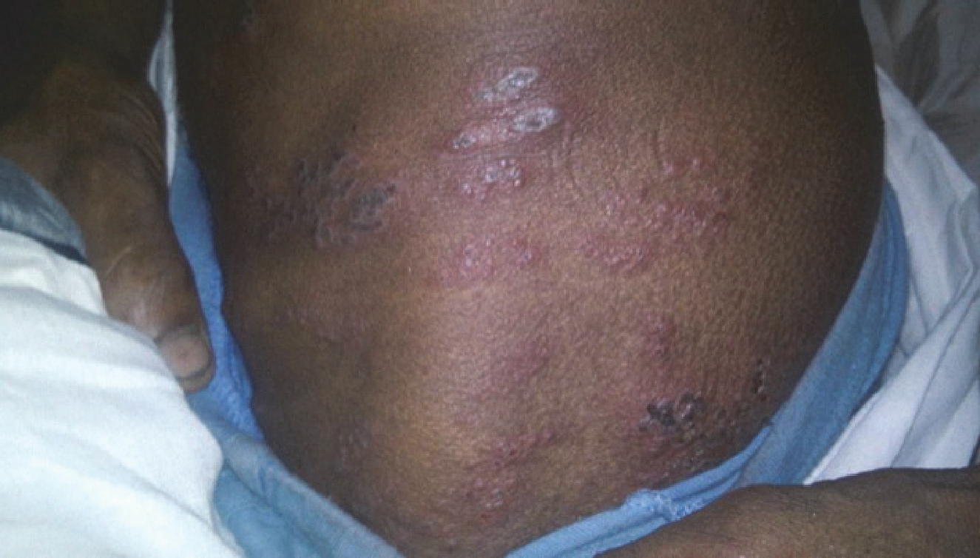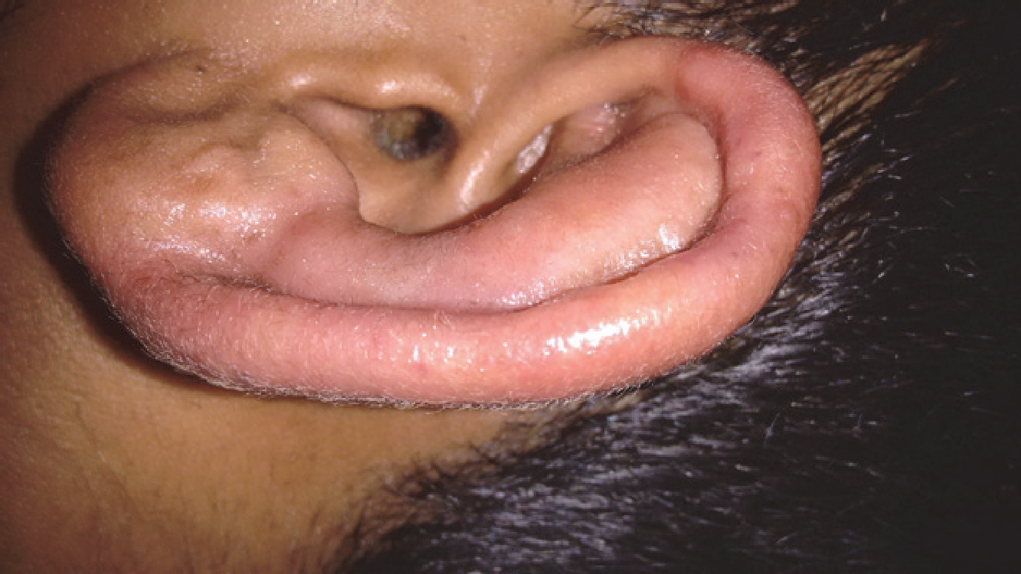

Redness and swelling of cartilaginous upper two-thirds of the external ear.
Citation: Punit Pruthi, Hariharan Munganda, Amit Bangia, Uma Rani, Rajesh Budhiraja, and Swapnil Brajpuriya, “Leprosy with Atypical Skin Lesions Masquerading as Relapsing Polychondritis,” Case Reports in Infectious Diseases, vol. 2016, Article ID 7802423, 3 pages, 2016. https://doi.org/10.1155/2016/7802423.

Infect51: Tuberculosis

HISTORY
The patient was a 40-year-old male shopkeeper with complaint of pain and a mass in right side of chest cage. The symptoms started 20 days ago in right lower part of back of chest which had increase in size gradually, with cough, sputum, fever and chills, pleuritic chest pain, and dyspnea. The patient indicated loss of appetite and loss of weight of approximately 7 kg in recent 20 days. There was no history of diabetes mellitus, hypertension, surgery, or blood infusion and there was also no history of respiratory problems. The patient was married and his family relations had no recent infectious disease.The patient has been smoking 3-4 cigarettes per day for 15 years. He has been addicted to opium for 14 years, both orally and by inhalation, and he had a history of 2 years in jail.
PHYSICAL EXAMINATION

Vital signs were stable. No specific disorders were found in physical examination of head and neck, ear, nose, and lymphatic system. Heart sounds were normal. There was elliptical bulge of cm in lower part of back of right side of the chest(Figure 1). There was no fluctuating in palpation but there was mild tenderness. There was wheezing heard in lower part of right chest cage. But no rale and decrease in sound were found.

In chest X-ray, a soft tissue thickness was detected. The right costophrenic angle was blunt but with or without significant fluid. Left diaphragm became flat which could be possibly because of an old problem and there was no subpulmonic effusion. Fibrosis was seen in the apexes especially in the right one

LABORATORY DATA
CBC, LFT, and electrolytes were normal (PPD: 25 mm, CRP: ++, and ESR: 65 units).
Citation: Babamahmoodi, Farhang et al. “Tuberculous Empyema Necessitatis in a 40-Year-Old Immunocompetent Male.” Case Reports in Infectious Diseases 2016 (2016): 4187108. PMC. Web. 21 Oct. 2018.

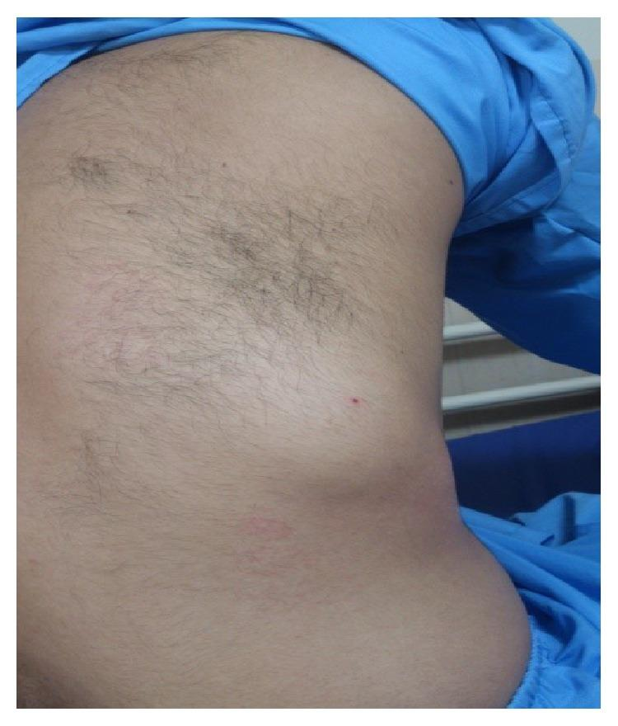

Infect52: Pneumonia
HISTORY
A 66-year-old male presented to clinic with a 4-day history of dry cough, progressing to rusty colored sputum, sudden onset of chills the previous evening, subjective fever, and malaise. Originally, the man thought he had a cold, but the symptoms had worsened and he “barely slept last night with all this coughing.” He denied experiencing shortness of breath but suggested he may be breathing “a little faster than normal.”
He related that, on the way to the clinic, he felt some sharp right-sided chest pain after a particularly long bout of coughing. He denied any leg swelling, orthopnea, or left-sided/substernal chest pain. He also denied any gastrointestinal symptoms (no nausea, vomiting, or diarrhea). His past medical history included hypertension and hypercholesterolemia. He reported no antibiotic use in the previous three months.
PHYSICAL EXAMINATION
In general, the man appeared tired and a bit “washed out.” His vital signs were as follows:(i) Temperature (F): 101.3(ii)Blood pressure (mmHg): 128/76(iii)HR (bpm): 102(iv)RR (bpm): 24(v)SpO₂ (%): 94Respiratory examination revealed mild tachypnea with dullness to percussion over the lower-right lung. Auscultation revealed decreased breath sounds in the same area, but no crackles or wheezing.
Other than mild tachycardia with a regular rhythm, the remainder of the physical examination was normal. There was no jugular venous distention or pedal edema.
Citation: Glenn Harnett, “Treatment of Community-Acquired Pneumonia: A Case Report and Current Treatment Dilemmas,” Case Reports in Emergency Medicine, vol. 2017, Article ID 5045087, 7 pages, 2017. https://doi.org/10.1155/2017/5045087.

Infect53: Acute Viral Hepatitis
HISTORY
A 22-year-old man presented with malaise and anorexia for 1 week. He vomited on one
occasion, with no blood. He has felt feverish but has not taken his temperature. For 2 weeks he has had aching pains in the knees, elbows and wrists without any obvious swelling of the joints. He has not noticed any change in his urine or bowels. Five years ago he had glandular fever confirmed serologically. He smokes 25 cigarettes per day and drinks 20–40 units of alcohol per week. He has taken marijuana and ecstasy occasionally over the past 2 years and various tablets and mixtures at clubs without being sure of the constituents. He denies any intravenous drug use. He has had irregular homosexual contacts but says that he has always used protection. He claims to have had an HIV test which was negative 6 months earlier. He has not travelled outside Western Europe in the last 2 years. He is unemployed and lives in a flat with three other people. There is no relevant family history.

PHYSICAL EXAMINATION

He has a temperature of 38.6°C and looks unwell. He looks as if he may be a little jaundiced.
He is a little tender in the right upper quadrant of the abdomen. There are no abnormalities
to find on examination of the joints or in any other system.

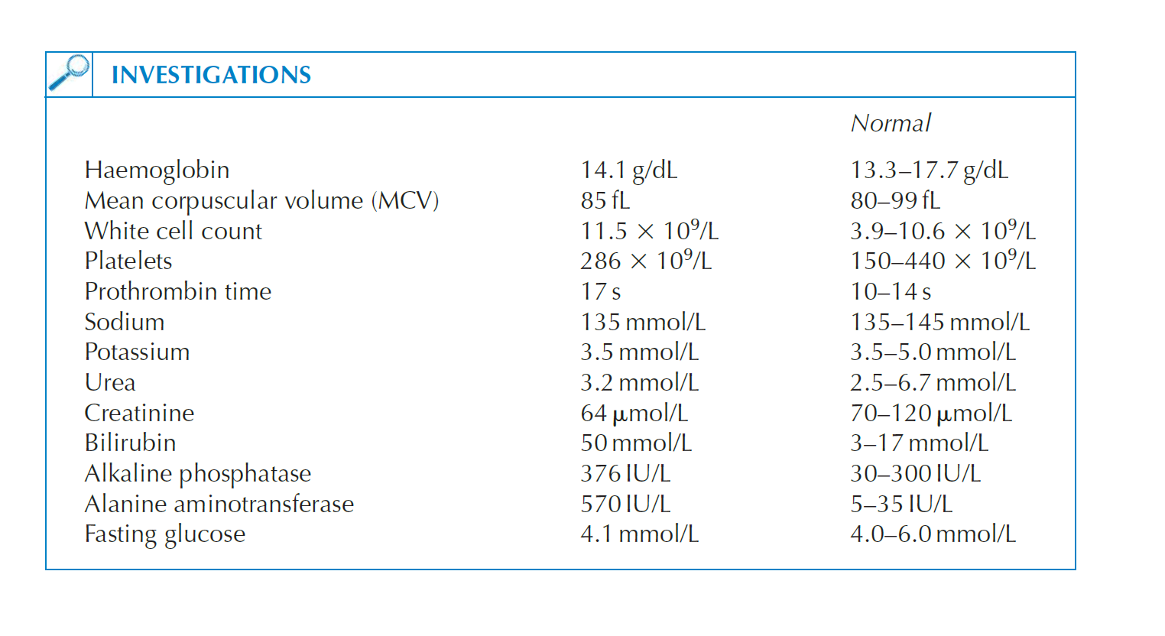
Citation: Rees, P John, James Pattison, and Christopher Kosky. 100 Cases In Clinical Medicine, Third Edition. 3rd ed. Hoboken: CRC Press, 2013.

Infect54: Urinary Tract Infection

HISTORY

A 7 year old girl presents with a chief complaint of abdominal pain which is described as intermitternt cramping pain since the past 2 days. The pain is described as severe and increases on urination. There is difficulty and a burning sensation on passage of urine. According to the mother the urine looks darker in color than usual. She also notices a fever with chills. The child has not been eating well and is feeling a generalized sense of discomfort. Otherwise the child has been healthy and does not have a significant past medical history. Bowel movements are normal.

Infect55: Appendicitis

HISTORY

A 25 year old female gives a history of anorexia and periumbilical pain, nausea, right lower quadrant (RLQ) pain, and vomiting. In addition, when vomiting occurs, it nearly always follows the onset of pain. Patient denies history of diarrhea or constipation. She says the abdominal pain begin as periumbilical or epigastric pain migrating to the right lower quadrant (RLQ) of the abdomen. She usually lies down, flexes her hips, and draws her knees up to reduce movements and to avoid worsening her pain. Later, a worsening progressive pain along with vomiting, nausea, and anorexia are described by the patient. She does not have fever.
The duration of symptoms is less than 48 hours. The patient claims she is not sexually active.
Her past medical history and family history is insignificant.

PHYSICAL EXAMINATION

On physical examination, rebound tenderness is present in the right lower quadrant. Systemic examination reveals no abnormalities.

Infect58: Tuberculosis
HISTORY
A 20 year old female presents with chest pain with fever and chills. She gives a history of cough that has lasted more than six weeks. She has also been coughing up blood. She gives history of fatigue, night sweats and loss of appetite. Family history, social history and past medical history is not significant.

Infect59: Malaria

HISTORY

A 20 year old female patient presents with short duration of high grade intermittent fever with chills and rigors. She has taken over the counter antibiotics but her symptoms have not improved. The fever has been noted to increase in the evening on alternate days and patient has been feeling a generalized feeling of discomfort along with loss of appetite and nausea.

PHYSICAL EXAMINATION

On examination, she looks thin, weak and pale and splenomegaly is present.

Infect60 Cerebral Malaria

HISTORY
A 34 year old woman presents with a chief complaint of severe headache and convulsions for the past 12 hours. Also she has been experiencing high grade faver with chills and rigors for the past 5 days. There is a generalized feeling of discomfort. The person accompanying her reports that she lost consciousness a couple of hours ago. She also reports having increased heart rate and perspirations.

Infect61 Malaria
HISTORY
A 23-year-old presented to the clinic with abdominal pain for three days and a fever of 40°C. Besides an episode of malaria in the past (before 2008), he had no medical history. His travel history indicated a visit to a malaria-endemic country, Liberia, in 2008. Nine days before admission to our hospital, he returned from a four-week holiday in Barcelona, Spain and Treviso, Italy, where he traveled by car. During his travel, he stayed with immigrants who recently returned from Africa, some of whom were sick and had fevers. The patient reported that in both place where the living conditions were poor, and many indoor insects, including mosquitoes, were present. No other risk factors for transmission of malaria (e.g., intravenous drug use, blood transfusion, surgical interventions, airport visit) were reported.

PHYSICAL EXAMINATION
At a physical examination, he did not appear acutely ill. His blood pressure was 108/55 mm of Hg, his pulse rate was 84 beats/minute and his temperature was 40 °C. He had abdominal tenderness. There were no other abnormalities.

Laboratory test results showed hemoglobin level of 8.3 mmol/L, a thrombocyte count of 56 × 10⁹/L, a leukocyte count of 4.5 × 10⁹cells/L and a normal differentiation pattern, a C-reactive protein level of 127 mg/L, and a lactate dehydrogenase level of 278 U/L.

Citation: Arends, Joop E. et al. “Two Cases of Plasmodium Falciparum Malaria in the Netherlands without Recent Travel to a Malaria-Endemic Country.” The American Journal of Tropical Medicine and Hygiene 89.3 (2013): 527–530. PMC. Web. 21 Oct. 2018.

